

**TEFL – THE WORLD IS YOUR OYSTER**

120 HOUR COURSE ASSIGNMENT AND TASK ASSESSMENTS



TABLE OF CONTENT

* Final Assessment Assignment
* Example Essay – Teacher Sasha
* True and False questions
* Tables to complete

[](https://www.google.co.za/url?sa=i&url=https://thesayingquotes.com/success-quotes/&psig=AOvVaw1pDNFYmlH9D3Yt_pLGyP3S&ust=1593626981976000&source=images&cd=vfe&ved=0CAIQjRxqFwoTCJDqza6RquoCFQAAAAAdAAAAABAR)

**INTRODUCTION**

**FINAL EXAM**

Welcome to the final exam, once completed successfully you will obtain your certificate. Since you have been working diligently we are sure you will sail through with FLYING COLOURS. In this exam we will assess your knowledge attained from the NESKA short course 120 hour TEFL modules

Before you start your final exam – it is important for you to review information from your modules.

Before you start your final exam – it is important for you to review information from:

1) Introduction

2) Grammar

3) Words Galore

4) Lesson planning

The modules are full of useful tips, information and guidance to help you to pass your final exam with ease, be the best version of yourself.

Good-LUCK

NESKA Academic team

Get into your “think tank” let’s level up for your last stretch.



**NESKA SHORT COURSE - TIME TO EVALUATE**

120-Hour Written Assignment – 2 pages

Congratulations and welcome to your TEFL written assignment.

FINAL EXAM - WRITTEN ASSIGNMENT

TOPIC

BIBLIOGRAPHY





Thank you very much for taking the time to WRITE YOUR essay.

All the best.

NESKA academic team



Activity 1

Create 3 flashcards within an appropriate theme for a beginner student?

Example – theme body – words – ear, eyes, nose, mouth, hand 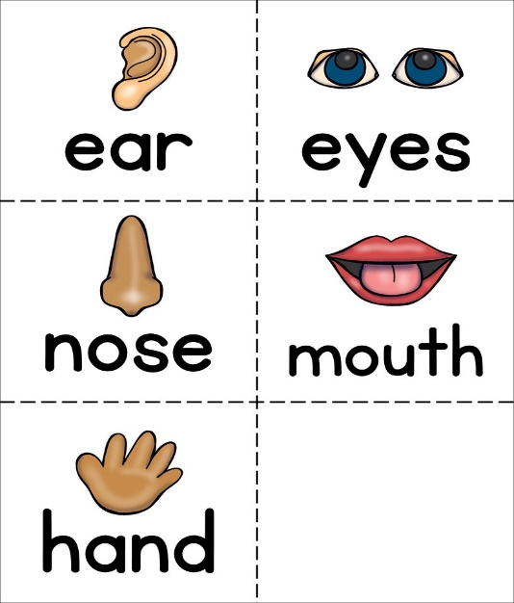

1)

2)

3)

True or False

1. English Idioms are literal and not figurative

True

False 

1. The idiom “tickled pink” means happy

True 

False 

1. The phrasal verb “get along” means frustrated

True 

False 

1. The teacher should make sure the student’s pronunciation is 100% perfect

True 

False 

1. When asking concept checking questions (CCQs) use the target language in your question to be more impactful

True 

False 



Complete the table below

Form of English words

|  |  |  |  |
| --- | --- | --- | --- |
| **Noun** | **Verb** | **Adjective** | **Adverb** |
| sadness | to sadden | a sad story | sadly |
|  |  |  |  |
|  |  |  |  |
|  |  |  |  |
|  |  |  |  |



Complete the table below:

Idioms:

|  |  |
| --- | --- |
| **Idiom** | **Meaning** |
| Tickled pink | Happiness |
|  |  |
|  |  |
|  |  |

Complete the table below:

Phrasal verbs

|  |  |
| --- | --- |
| **Phrasal verb** | **Meaning** |
| Get along |  |
| Call off |  |
| Burn out |  |
| Hang out |  |



Complete the table

Analysing vocabulary

You need to present this in a table called a Language Analysis.

Have a look in your words galore module to see what a language analysis should look like, you will need to complete in this assignment.

|  |  |  |  |  |  |
| --- | --- | --- | --- | --- | --- |
| Language item | Language meaning | Present meaning | Concept checking questions | Grammatical form | Pronunciation |
| banana |  |  |  |  |  |
| computer |  |  |  |  |  |
| happy |  |  |  |  |  |
| beautiful |  |  |  |  |  |

Complete the table:

Adverbs of frequency

|  |  |  |
| --- | --- | --- |
| Always | 100% | She always finishes her tasks before the deadlines. |
| Usually |  | They usually go hiking once a month. |
| Normally |  | He normally visits his grandmother on thanksgiving. |
| Often |  | They often take road trips to the mountains. |
| Sometimes | 50% | He sometimes go surfing on Sunday mornings. |
| Occasionally | 30% |  |
| Seldom | 10% |  |
| Hardly ever |  |  |
|  |  | She rarely makes a mistake. |
|  | 0% | He never forgets a face. |
|  |  |  |
|  |  |  |

Thank you for completing your final exam. Your exam will be graded within 4-5 days and your certificate will be emailed to you. We wish you well in your TEFL journey.

Best Regards and GOOD LUCK!

NESKA academic team



