

**TEFL – THE WORLD IS YOUR OYSTER**

120 HOUR COURSE ASSIGNMENT AND TASK ASSESSMENTS



TABLE OF CONTENT

* Final Assessment Assignment
* Example Essay – Teacher Sasha
* True and False questions
* Tables to complete

[](https://www.google.co.za/url?sa=i&url=https://thesayingquotes.com/success-quotes/&psig=AOvVaw1pDNFYmlH9D3Yt_pLGyP3S&ust=1593626981976000&source=images&cd=vfe&ved=0CAIQjRxqFwoTCJDqza6RquoCFQAAAAAdAAAAABAR)

**INTRODUCTION**

**FINAL EXAM**

Welcome to the final exam, once completed successfully you will obtain your certificate. Since you have been working diligently we are sure you will sail through with FLYING COLOURS. In this exam we will assess your knowledge attained from the NESKA short course 120 hour TEFL modules

Before you start your final exam – it is important for you to review information from your modules.

Before you start your final exam – it is important for you to review information from:

1) Introduction

2) Grammar

3) Words Galore

4) Lesson planning

The modules are full of useful tips, information and guidance to help you to pass your final exam with ease, be the best version of yourself.

Good-LUCK

NESKA Academic team

Get into your “think tank” let’s level up for your last stretch.



**NESKA SHORT COURSE - TIME TO EVALUATE**

120-Hour Written Assignment – 2 pages

Congratulations and welcome to your TEFL written assignment.

The purpose of this final assignment is to check your knowledge related to teaching English as a foreign language.

An example of an essay written by TEFL Teacher Sasha has been attached here for your kind perusal. Her focus area being *lesson planning* you may choose your area of research.

Once you have completed your answer, click on 'Submit all and finish'. Your answer will be sent to a tutor to be graded. All written assignments can take up to 4-5 days not including weekends or holiday to be marked. After your tutor has graded and provided feedback and your certificate.

You will be asked to review the feedback, adjust your answers and re-attempt if you have not successfully answered the question.





**EXAMPLE OF AN ESSAY**

WRITTEN BY SASHA GLOBAL ESL TEACHER

Lesson planning is crucial in the teaching and learning process as it adequately prepares the teacher for the lesson. It ensures that the learning aims and objectives are achieved. It also prepares teachers, as they can access all resources needed prior to the lesson. Well prepared teachers are more likely to have control in the classroom and are able to handle any situation that may arise. Planning also helps with time management as the teacher will choose suitable activities to be completed in the given time. My lesson plan will offer me guidance throughout my lesson. It will help me stay focused and in line with my current aims. I will walk into the classroom confident because I have a plan.

I have structured the lesson plan in the following way because I had to think about the capabilities of my students. Activities I have used take into consideration the age difference and the concentration levels of the group. Throughout my lesson, I kept in mind that English is their second language, therefore my lesson had to be simple and spoken at a slower pace to allow them to grasp the concepts with ease. I have made activities vey student centred hence students will be constantly interactive during the lesson.

In the warm-up stage, I used an activity in the form of a memory game to get the students focused. This increases the student’s concentration, participation and interactivity when they are presented with something more challenging as the lesson goes on. Introverts get an opportunity to participate in groups comfortably and not answer questions.

In the presentation stage, the oral activity to be done with the students introduces the new vocabulary of the target language. I have included images for this activity because I want students to be aware of the physical meaning of the word so they can link the description with the noun. They will understand the concept of describing people by choosing the relevant relief to correspond with the appropriate describing words. I have included drilling and modelling to ensure that the correct pronunciation of the words are learnt. When planning the activity for the Practice stage. I had to bear in mind that not all students would grasp the describing words in the same way, this is because the student’s level of understanding is different. I therefore included two different worksheets for the different age groups. The six and seven year olds will complete a different worksheet form the eight year olds. I structured the questions according to the type of questioning familiar to each age group. The six and seven years olds are capable of completing a “Matching” activity worksheet and the eight year olds are capable of completing a “Gap Fill” worksheet. The use of pictures in these worksheets will help students to get the correct answer. In the production stage, I want to test how much the student knows. The activities I have included in this stage will allow them to practice the new target language individually and then through games in groups. Group work and educational games allow students to interact and become competitive (in a motivational way) with each other. Educational games also makes learning enjoyable and it increases the student’s attention.

I have chosen this topic “Describing People”) because it deals with the students themselves. They are physically able to see differences in others which make it easy for them to remember the target language. Example. Jane has long hair. Students will relate the word LONG to Jane’s hair.

The target language I have chosen to teach is simple enough to show the students these differences. Something shown to them visually is more likely to be remembered for a long period of time. .Teaching them differences in people, example, short-tall, also introduces anonyms into the lesson. They will be able to think critically and associate short with tall. I also want to motivate my students to use describing words to make their sentences interesting. Ï am a girl “is a simple sentence, it can become more colourful and interesting by adding describing words to it. “I am tall, blue eyed girl, it get them to think at a level beyond ordinary. They will understand that describing someone is to identify how the person look and wear.

When teaching this lesson, the students may face a number of challenges. Possible difficulties could be that the students are unable to understand the target language being taught due to the language barrier. English not being their first language, can be difficult for some of the students to follow instructions. Not being able to understand the topic and the instructions given by the teacher to cause the students to lack concentration. This can open form for distracted students to start talking to their peers. Due to their age differences the class, all students attention span are different. The younger students may not be able to concentrate for a full sixty minute lesson on describing words, they become restless lose focus on the lesson. There also lies danger when asking students if they understand what is being taught. The introvert students will say they understand even if they don’t, because they don’t want to be seen as weak to the rest of the class. They may also be afraid that the others would laugh or pick on them. All the activities I have included in my lesson will contribute towards the learning aims. The warmer activity allows for students to see the difference in people’s appearance without being taught the target language. The activity used in the Presentation teaches students the new describing words and the use of realis will help them understand how describing words link to people. On completion of this activity, students will have learnt the ten new target words. The activity used the in Practice tests and what students remember from the Presentation Stage. On completion of this activity, students will have learnt the ten new target words. The activity to be completed in this stage tests students understanding on describing people. On completion of the activity, students will be able to relate those words to people outside of the classroom. The activities used in the Production stage, tests how much students can recall from the lesson. The activities will help build students confidence and improve their reading and writing skills.

1. A song describing a person – the song was fun and entertaining and grasped the interest of my learners.
2. A short clip video- students enjoy the fun video and gave more exposure to my theme.

There are a number of activities I considered using but didn’t are as follows:

1. Describing what you see in the picture – Students will find it difficult to construct sentences due to the limited vocabulary they know.
2. Role play – due to the language barrier this may limit interaction and difficulty to understand the role play. The personalities of the learners differ so when planning my activities I thought about simple activities that could work for everyone.

The activities I have planned for my lesson may not always be successful. It all depends on how well the students understand the topic and how interested they are in the lesson. Throughout the lesson I will be aware of how the class is responding to my questions and monitor how capable they are of correctly completing the activities. If I have the loss of students attention in any activities. I will play a game. If few students have difficulties in completing the activities, I will assist individually to help create a better understanding.

The lesson plan I created is a guide that will help me reach the desired outcomes. I will be flexible and adaptable in class, and in the end of my lesson, I will reflect and evaluate, what worked? What didn’t? My students walked out taking value from my lesson and had a fruitful learning experience.

Thank you very much for taking the time to read my essay.

All the best.

Sasha

NESKA academic team



Activity 1

Create 3 flashcards within an appropriate theme for a beginner student?

Example – theme body – words – ear, eyes, nose, mouth, hand 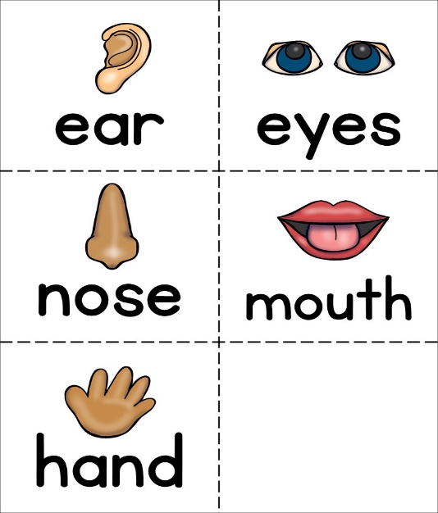

1)

2)

3)

True or False

1. English Idioms are literal and not figurative

True

False 

1. The idiom “tickled pink” means happy

True 

False 

1. The phrasal verb “get along” means frustrated

True 

False 

1. The teacher should make sure the student’s pronunciation is 100% perfect

True 

False 

1. When asking concept checking questions (CCQs) use the target language in your question to be more impactful

True 

False 



Complete the table below

Form of English words

|  |  |  |  |
| --- | --- | --- | --- |
| **Noun** | **Verb** | **Adjective** | **Adverb** |
| sadness | to sadden | a sad story | sadly |
|  |  |  |  |
|  |  |  |  |
|  |  |  |  |
|  |  |  |  |



Complete the table below:

Idioms:

|  |  |
| --- | --- |
| **Idiom** | **Meaning** |
| Tickled pink | Happiness |
|  |  |
|  |  |
|  |  |

Complete the table below:

Phrasal verbs

|  |  |
| --- | --- |
| **Phrasal verb** | **Meaning** |
| Get along |  |
| Call off |  |
| Burn out |  |
| Hang out |  |



Complete the table

Analysing vocabulary

You need to present this in a table called a Language Analysis.

Have a look in your words galore module to see what a language analysis should look like, you will need to complete in this assignment.

|  |  |  |  |  |  |
| --- | --- | --- | --- | --- | --- |
| Language item | Language meaning | Present meaning | Concept checking questions | Grammatical form | Pronunciation |
| banana |  |  |  |  |  |
| computer |  |  |  |  |  |
| happy |  |  |  |  |  |
| beautiful |  |  |  |  |  |

Complete the table:

Adverbs of frequency

|  |  |  |
| --- | --- | --- |
| Always | 100% | She always finishes her tasks before the deadlines. |
| Usually |  | They usually go hiking once a month. |
| Normally |  | He normally visits his grandmother on thanksgiving. |
| Often |  | They often take road trips to the mountains. |
| Sometimes | 50% | He sometimes go surfing on Sunday mornings. |
| Occasionally | 30% |  |
| Seldom | 10% |  |
| Hardly ever |  |  |
|  |  | She rarely makes a mistake. |
|  | 0% | He never forgets a face. |
|  |  |  |
|  |  |  |

Thank you for completing your final exam. Your exam will be graded within 5-7 days and your certificate will be emailed to you. We wish you well in your TEFL journey.

Best Regards and GOOD LUCK!

NESKA academic team



